SYSTEMATIC LISTING
Pearson Edexcel - Thursday 7 June 2018 - Paper 2 (Calculator) Foundation Tier

Pearson Edexcel – Specimen 1 - Paper 1 (Non-Calculator) Foundation Tier

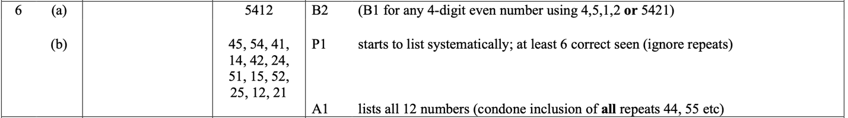
Pearson Edexcel – Sample Papers - Paper 1 (Non-Calculator) Foundation Tier

OCR Tuesday 13 June 2017 – Morning (Calculator) Foundation Tier

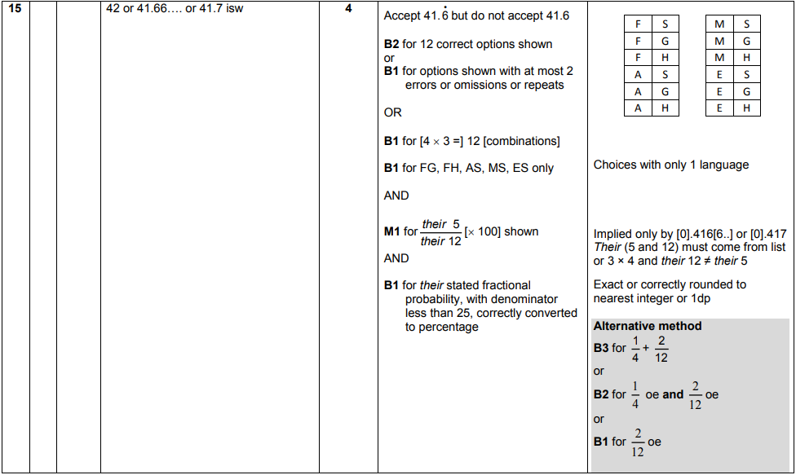
AQA Monday 8 June 2020 – Morning (Calculator) Foundation Tier

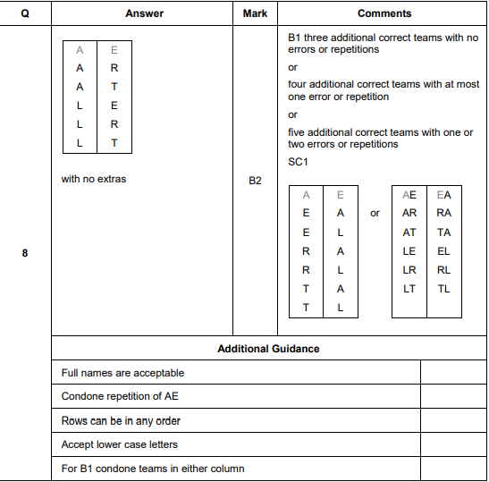

AQA Thursday 11 June 2019 – Morning (Calculator) Foundation Tier

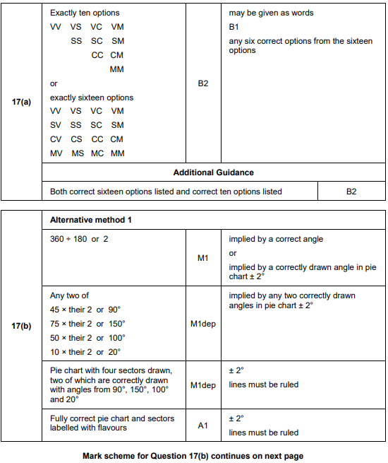

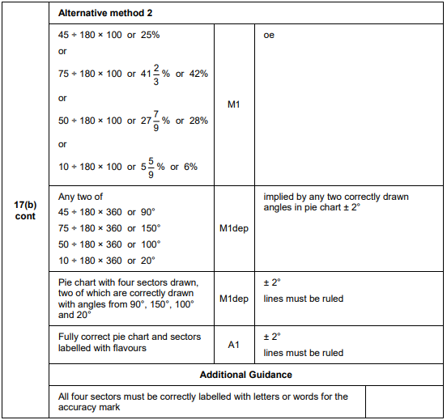
AQA Thursday 8 November 2018 – Morning (Calculator) Foundation Tier

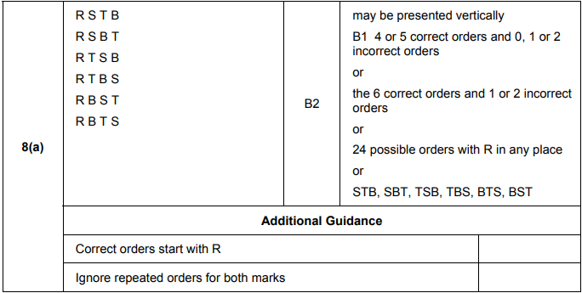
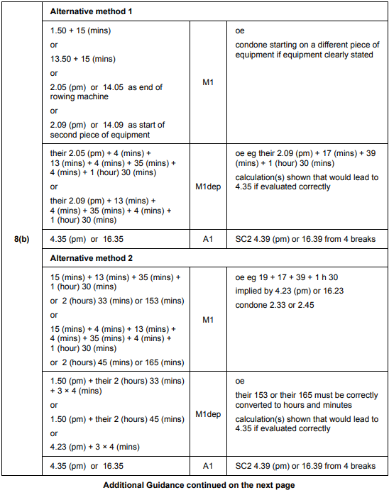
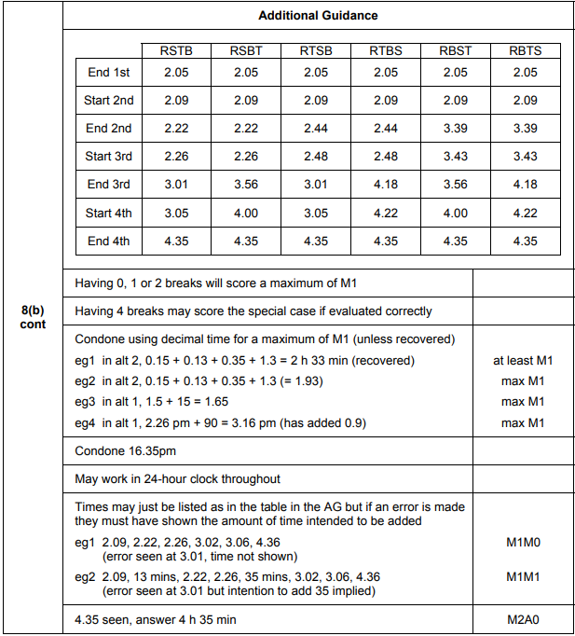

AQA Tuesday 12 June 2018 – Morning (Calculator) Foundation Tier

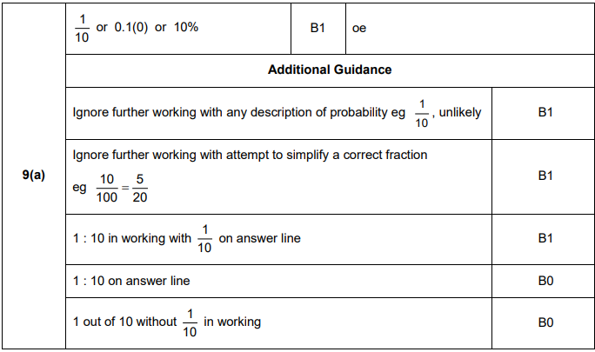
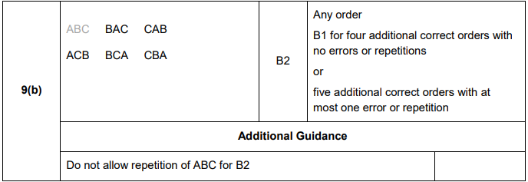

AQA Wednesday 8 November 2017 – Morning (Calculator) Foundation Tier

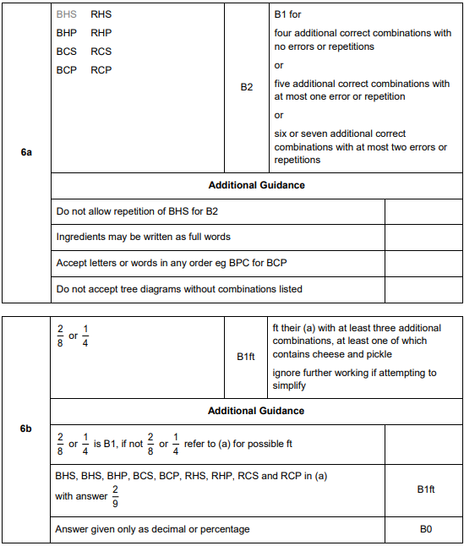

AQA Tuesday 13 June 2017 Morning– Morning (Calculator) Foundation Tier

